ON THE APPLICATION OF ONLINE GAMING INDUSTRY

*Submitted to the*

**SAVEETHA INSTITUTE OF MEDICAL AND TECHNICAL SCIENCES**

In partial fulfillment for the completion of the

**SECOND year Project**

**by**

J.THARUN- 192110195(CSE)

B.SAKETH-192111737(CSE)

**Under the guidance of**

**K.VIJAYBHASKAR**

**Assistant Professor**



**INSTITUTE of SCience and HUMANITIES**

**SAVEETHA SCHOOL OF ENGINEERING**

**CHENNAI – 602 105**

**TAMILNADU, INDIA**

**SEPTEMBER 2022**

**BONAFIDE CERTIFICATE**

This is to certify that the project report entitled **“On the Online Gaming Industry”** submitted by “J.Tharun & B.saketh, to Saveetha School of Engineering, Saveetha Institute of Medical and Technical Sciences, Chennai, is a record of bonafide work carried out by him/her under my guidance. The project fulfills the requirements as per the regulations of this institution and in my appraisal meets the required standards for submission.

|  |  |
| --- | --- |
| **K.Vijay Bhaskar**  Supervisor  Assistant Professor  Department of Programming  Saveetha School of Engineering  SIMATS, Chennai – 602 105 |  |

**Internal examiner External Examiner**

|  |  |  |
| --- | --- | --- |
| **S.No** | **CONTENTS** | **Page No** |
| 1 | Abstract | 4 |
| 2 | Introduction | 6 |
| 3 | Objectives | 5 |
| 4 | Literature Review | 7 |
| 5 | Conclusion | 12 |
| 6 | Suggestions | 14 |
| 7 | References | 16 |

**ACKNOWLEDGEMENT**

I take immense pleasure in expressing my gratitude to our Honourable Chancellor **Dr. N. M. Veeraiyan** for being our constant source of inspiration.

I sincerely thank our Vice-Chancellor, **Prof. Dr. Rakesh Kumar Sharma** for providing the academic ambience to complete the project successfully.

With profound gratitude, respect and pride, I express my sincere thanks to our Director, **Mrs. Ramya Deepak**, whose enthusiasm and dynamism being the driving force behind all our accomplishments.

I take this opportunity to extend our heartiest thanks to our beloved Principal, **Dr.B. Ramesh** for providing us excellent facilities and unstinting support which were the sustaining factors in carrying out the work successfully.

It is a genuine pleasure to express my deep sense of thanks and gratitude to my mentor and my project guide **K.VijayBhaskar,** Assistant Professor of Principles Of Management, Department of Programming. His timely advice, meticulous scrutiny and scientific approach have helped me to a very great extent to accomplish this task and also his dedication and keen interest had been solely and mainly responsible for completing my work.

Last, but not least, a very special thanks to my parents and friends for their moral support and care extended during the demanding times.

ONLINE GAMING INDUSTRY

ABSTRACT :

In this modern era, technology plays an important role in every walk of human life. People are using the latest technologies for information and entertainment which are providing wide rages of benefits to human community. For infotainment people are depending on social media and online gaming in advanced model. In this virtual world online gaming touches its highest level. Online game is a video game that is played with the help of internet or any other computer network available. Some people consider online gaming as a mode of entertainment. In this generation with the development of mobile industry and network industry has helped in the growth of online gaming industry. Online Gaming is also used as a tool to escape from stress in life.

OBJECTIVES :

Altogether, playing online games help players develop -

* solving skills, leadership skills, and the ability to deal better with unexpected consequences.
* To prepare students to work in teams. to prepare students to improve their skills and knowledge related to specific job positions individually.
* To develop creativity and individuality in problem solving and performing tasks. To enable students to do self-study.
* Online gaming is one of the widely used leisure activities by many people. For some people it is said that playing video games has a number of reasons to be played.
* For it can be a stress reliever, challenge and competition, relaxation, enjoyment, social interaction, and even mentally escaping from the real world.

INTRODUCTION :

Nowadays Online gaming is a major trend all over the world. One can play games if he/she has an internet access. There are games which gives us opportunity to compete with people that we haven’t met yet and also it is very possible to develop talent. Through online gaming we can also keep in touch with our friends. Online games are splendid because there are games that we can earn from. Even though online gaming is very pleasurable experience for many but it may also have pros and cons. online gaming is constructive because it can evade people especially youths from getting involved in the dangerous behaviour such as drugs and joining youth gangs. Online gaming exhilarates people and galvanize for competing with others. And also it makes player mentally vigorous and sharper too. At the same time online gaming may have more harmful effects than good. New generations may face lots of health issues mainly due to lack of physical movements. Online gaming may cause addiction and can consume time that meant for other activities. Online games may lead to online abuse. Mainly children playing are cornered in this. They may also download games from sites that may contaminate computers with virus.

* Gaming Industry is the economic sector involved in the development, marketing and monetization of games. Gaming Industry In India is valued at 60 Billion in 2019 and is expected to reach 250 Billion in 2024.
* The gaming industry is growing in India with a very high growth rate because India has the world’s largest youth population and embracing the new generation’s interest in digital sports and entertainment.

**LITERATURE SURVEY:**

# (1)**Lakshmi, Raja, Pujam, Nandha Kumara; Indian Journal of Health &amp;**

**Wellbeing.2015, Vol. 6 Issue 8, p820-822.**Internet has become the part of our life for last one decade. In India use of internet gaming is more among students and there is a question whether it leads to addiction. From the study of 200 students in Kerala and Tamil Nadu, 9% from Tamil Nadu and 12% from Kerala have depression due to internet gaming addiction.

(2) **Sudha R; The effect psycho physiological of playing violent video games among children, January, 2012, page 226.**Among adolescents and youth online gaming has become more addicted and its continuous usage has made individuals intention to harm others. Most researchers also focused the same. Over past 3 decades, violent online games become socializes of children and its effects made aggressive thoughts, angry, psychological problems in the real world.

## **Player type study **:****

## One of the major concern about MMORPGs study is to identify the motivations of game players to engage in gaming environments. Bartle’s (1996) player taxonomy was among the first studies to describe player motivations in virtual worlds. Bartle’s (1996) player type theory was stated that there are four main reasons why people continue playing Multi-User Dungeon (MUDs: ancestors of MMORPGs) which are to achieve in the game, imposition others, explore through the game, and socialize with other players. This theory first start off with taxonomy of game players of MUDs or Multi-User Dungeon which is the multiplayer online game that allow many players to join at the same time. According to Bartle’s player type theory, there are four things that people typically enjoyed personally about MUDs were:

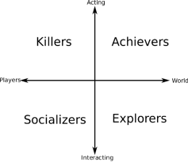

TRIUNE BRAIN THEORY :

Triune Brain theory was invented by Paul McLean in 1968. The theory itself separate human brain into three layers which works differently for each part (McLean, 1990). It consists of the reptilian brain (core brain), the limbic system (mid layer), and the cerebral system (outer layer) (McLean, 1990â€¬) which is described as follows:

The Reptilian brain functional to controls every basic function of our living. It maintains patterns and habits of human body and controls primitive behaviour, sensation, and survival. Environment does minimal effects to this part of brain.

The Limbic system is considered to be primary centres of emotion thinking, form and sequence which play a key role in memory transformation and retrieval (Andrew, 2001). McLean acknowledges that the senses we feel about the rationality of our thoughts has its roots in this system of emotional intelligence (McLean, 1990).

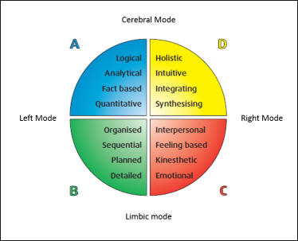

Zee(2003) and Young (2005) also mentioned :

1. Excessive mental effort on internet
2. Spending hours even though being intended to spend couple of minutes
3. Exposure to health problems due to spending hours in front of the screen each time
4. Continuously waiting for the next connection time
5. Feeling more comfortable contacting people over internet than talking face-to-face
6. Decrease in meals, lessons or work efficiency due to using internet or staying connecting
7. Trying to give or spread the mail address, chat room names etc to everybody
8. Continuously feeling sleepless and tired because of staying connected to the internet until late
9. Having failure in attempts to decrease the internet usage
10. Withdrawal syndrome due to increase in the internet usage
11. Telling lies to family members, therapist or others to be able to stay connected to the internet
12. Having affection changes in the duration of internet connection (Young, 1999; cited in *et. al*., 2007; cited in, Balta 2008).

#### ADVANTAGES :

#### **It helps reduce stress.**

#### **It elevates one’s mood.**

#### **It enhances the development of social skills.**

#### **It improves concentration.**

#### **It provides a source of income.**

DISADVANTAGES :

1. Physical Health Issue.
2. Insomnia.
3. Lack of concentration.
4. Poor Academic performance.
5. Lead to social isolation.

RESEARCH METHADALOGY:

Descriptive associational research method has been used for this study. The aim of the descriptive perspective is to determine related cases. This type of research is used to demonstrate associations and relations between two and more variables (KASHMIR, 2009).

The Population and Sample of the Study:

The population of this research involves all high school students in North Cyprus. The sample for the research consists of 61.8 % (n=81) female, 38.2 % (n=50) male, total 131 high school students. The sample was selected through criterion sampling method of the purposive sampling. Students who had their own personal computers were set as a criteria.

It is inferred that 8.5% of respondents strongly agree that they use online gaming as a way of escaping from stress, 31% of respondents agree, 32.5% of respondents may or may not agree, 8% of respondents strongly disagree that they do not use online gaming as a way of escaping from stress and remaining 20% of respondents disagree.

Comparing Students’ Gender with

Online Game Addiction Scale Scores

|  |  |  |  |  |  |  |  |
| --- | --- | --- | --- | --- | --- | --- | --- |
| **Subscales** | **Gender** | **N** |  | **Sd** | **df** | **F** | **p** |
| **Troubles** | **Female**    **Male** | 81    50 | 1.57    2.28 | .64    1.06 | 129    71.79 | 25.11 | .000** |
| **Success** | **Female**    **Male** | 81    50 | 2.38    3.26 | 1,15    1.12 | 129    105.6 3 | .773 | .000** |
| **Economic**  **profit** | **Female**    **Male** | 81    50 | 1.42    2.38 | .59    1.34 | 129    61.28 | 50.60 | .000** |
| **OGA General Scores** | **Female**    **Male** | 81    50 | 1.85    2.67 | .71    .88 | 129    87.88 | 1.50 | .000** |

FINDINGS:

* For the google survey the total number of responses we

get is 40.

* It is about the development of online gaming industry from past years.
* The responses we got on type of games you like
* Action-adventure :- 59%
* Simulation :- 7.1%
* Multi-player :- 28.9%
* Strategic :- 5.1%
* The opinion on online games
* It gives entertainment :- 71.1%
* It reduces stress :- 28.9%
* The favourite games among them
* GTA V :-23.1%
* FREE FIRE :-43.6%
* PUB G :-25.6%
* GOD OF WAR :-7.7%
* Is online games helps to develop skills
* Yes :-82.1%
* No :-17.9%
* Rating on online gaming industry
* 1 :- 2.6%
* 2 :- 0%
* 3 :- 28.2%
* 4 :- 30.8%
* 5 :- 38.5%
* Comment your favourite game
* BGMI :-15.6%
* FREE FIRE :-84.4%
* Do you think professional gamers are similar to athletes
* Yes :-56.4%
* NO :-43.6%

DATAANALYTICS :

It is about the online gaming industry development and people’s response on the online gaming. The responses are recorded from the google forms.

There are mainly four types of games :

1.Action-adventure

2.Simulation

3.Multi-player

4.Strategic

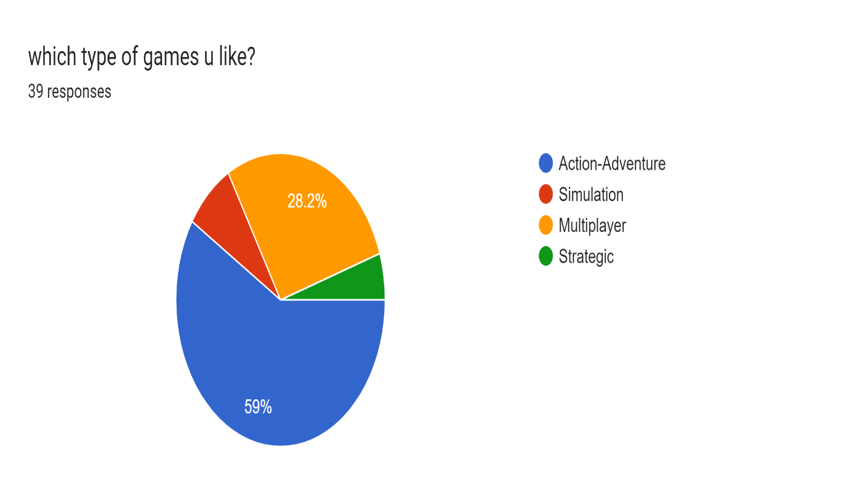

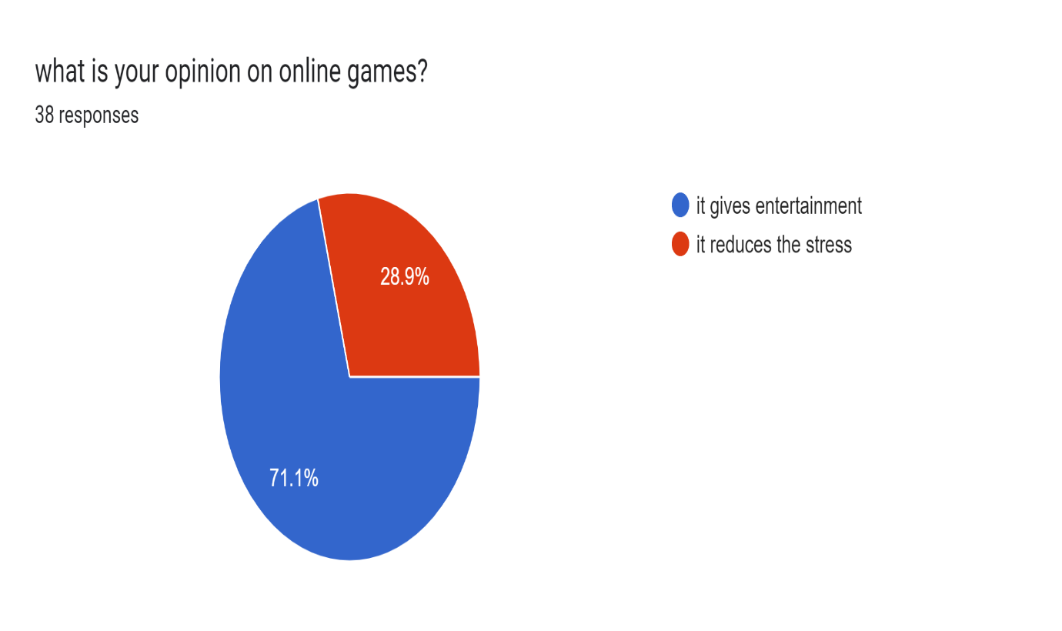

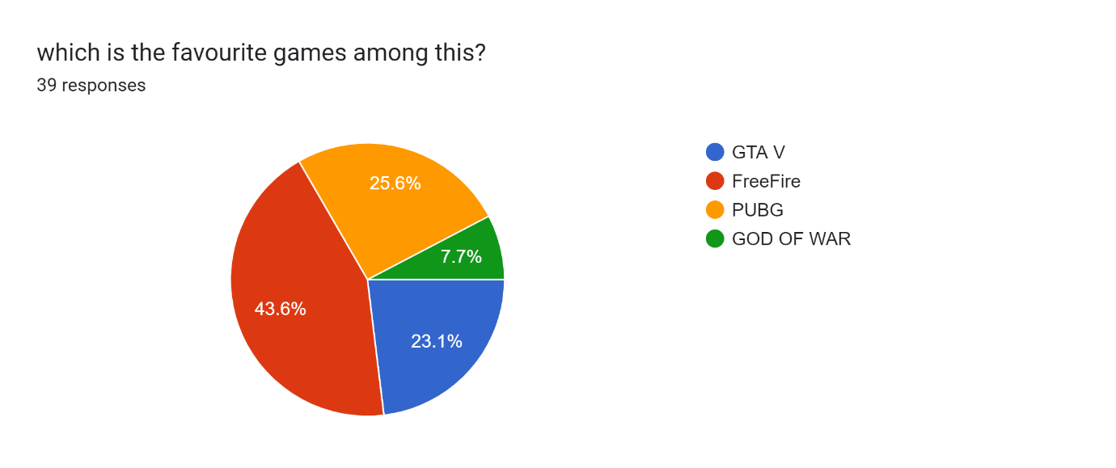

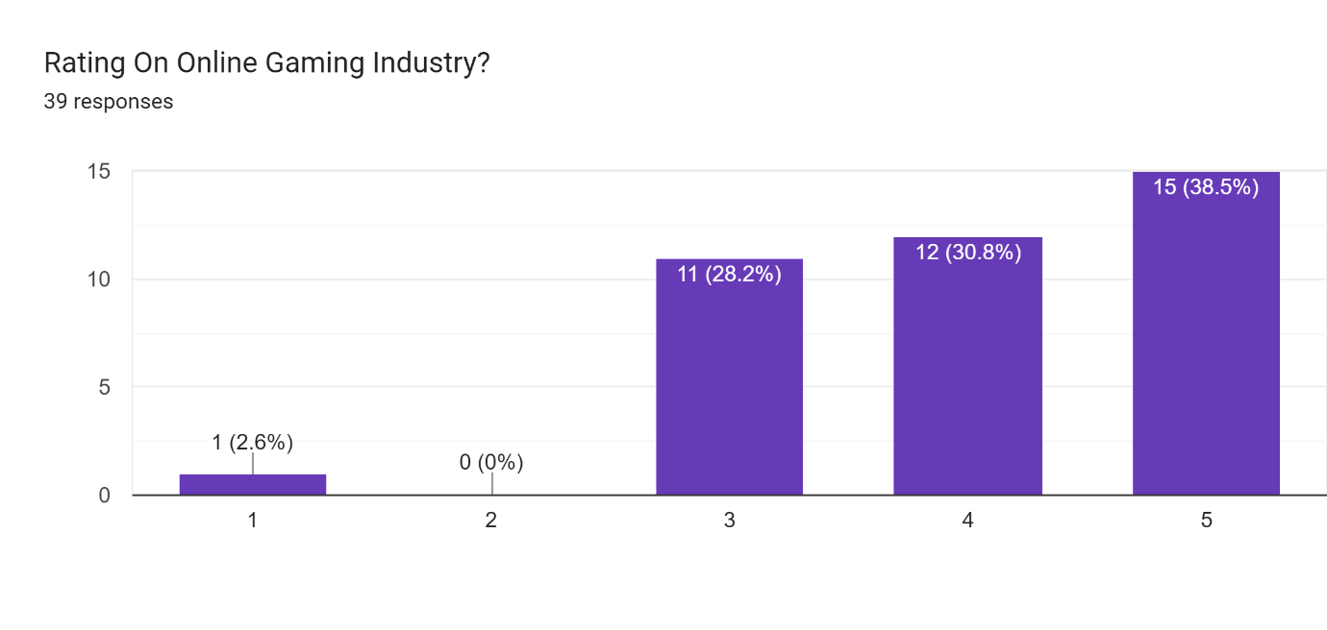

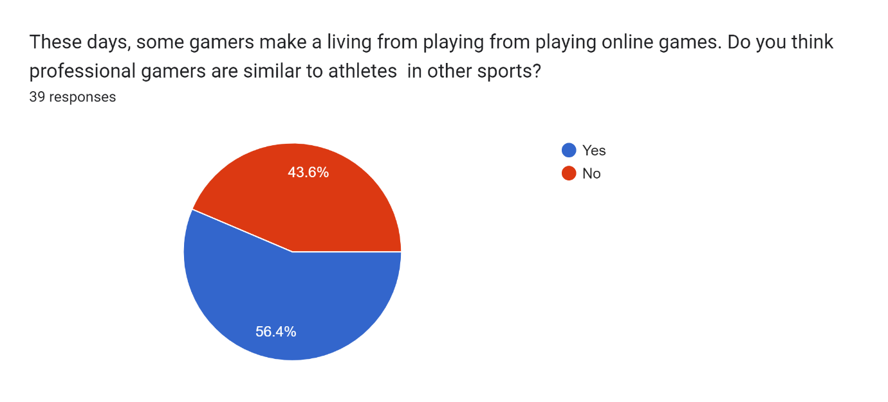

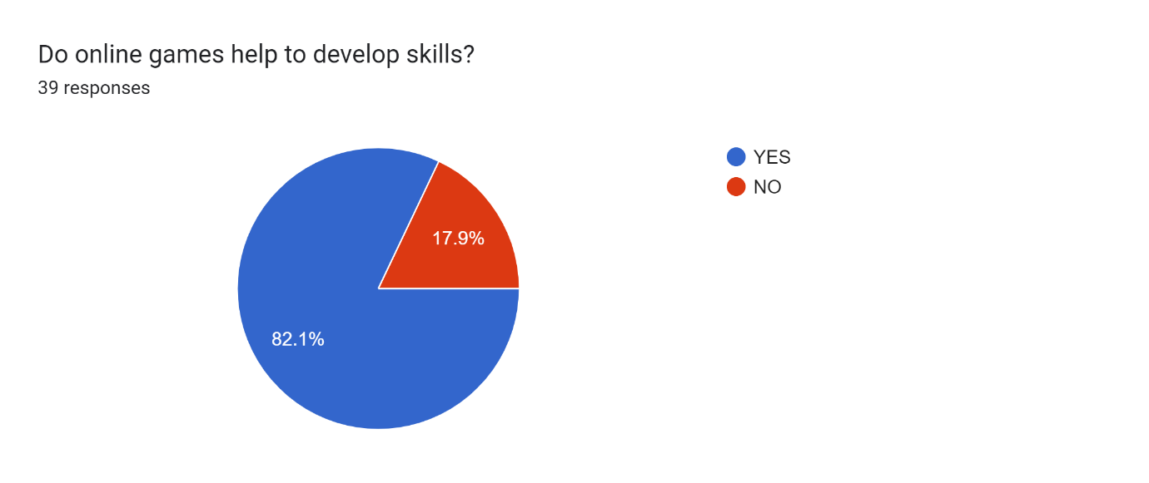



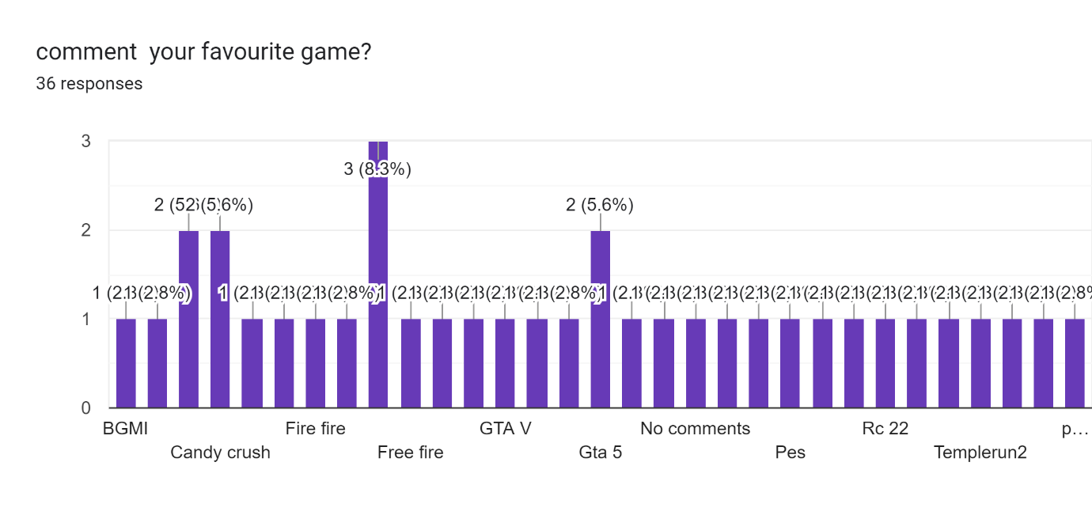

FUTURE ENHANCEMENT of Gaming Industry:

1. Age and gender dominance is likely to improve in the near future. Online gaming will soon see a shift in the age and gender composition of the total population since the huge untapped market is likely to experience this world of gaming

2. Cloud gaming is going to get very popular especially in India. All people would need to have is a stable internet connection and they could get an experience of gaming like never before.

3. Freemium companies will help the industry to get better economic conditions. We are a very price-sensitive market and freemium gamers would continue to search for alternatives if the companies start charging for premium services.

4. Emerging technologies will help our country to uplift the gaming industry even more. The use of artificial intelligence augmented reality in games, virtual reality, modular technology, and cloud based gaming infrastructure will be the key drivers of the gaming industry in the future.

# SUGGESTIONS :

* In order to reduce the addiction on online gaming among adolescent the Government should initiate some awareness programs and counseling.
* Engage oneself more in outdoor games such as football, cricket, badminton etc…other than stuck in front of an electronic device like mobiles, laptop, tabs etc…
* Instead of playing continuously, start tracking your gaming time and set a limit for yourself. It can be done by choosing games wisely or else go on gaming detox.
* One can also include yoga and meditation in daily routine which is an amazing way for stress relief and also it lend a hand to improve your concentration so that you can diminish your level of addiction.
* Evade the gambling games like online casino games which cause monetary loss.
* Elude extremely violent games like PUBG, because it can trigger aggressive thoughts, emotions, behaviour that ultimately affects the mental health of the player.

CONCLUSION :-

Online gaming has emerged as a popular and successful source of entertainment and played by people of all ages, especially by youth. Its main aim is to entertaining people and also indirectly to make them addictive to improve gaming industry. From this study, we got the information that there is a neutral online gaming effect in Kerala. It shows the Ernakulam district has more addictive to adventure games like PUBG among the male category. Through this study we also analyzed that continuous playing will causes its addiction and addiction to online games affects various dimensions of health, increases sleeplessness, and reduces direct social interactions. On the positive side online games helps in enhancing mental development, critical thinking and stress relief also. As an outcome of the study, it can be concluded that the online gaming has its positive and negative impacts in the real world.

REFERENCES:

Church-Sanders, Rachel. "Special Report: Online Poker – Industry Trends." IGB Affiliate. Web. 4 April 2016. http://www.igbaffiliate.com/resources/articles/special-report-online-poker-%E2%80%93-industry-trends.

1. Grubb, Jeff. "Gaming advocacy group: The average gamer is 31, and most play on a console."VB. VentureBeat.29April2014,Web2016. Books and Articles.
2. Article from down to earth.
3. Article from Journal of Behavioural Addictions, March 2012.
4. Article from International Journal of Scientific Engineering and Research, October 2017.
5. Article from Times of India.

Webliography :

1. https://en.wikipedia.org/wiki/Online_game.
2. https://timesofindia.indiatimes.com/india/gaming-addiction-is-a-mental-disorder-worldhealth-organisation/articleshow/64640781.cms
3. https://www.webmd.com/parenting/features/4-dangers-internet#1
4. <https://onlinelibrary.wiley.com/doi/full/10.1002/9781118767771.wbiedcs044>
5. https://www.quora.com/Is-PUBG-dangerous-to-play-Does-it-create-any-issues

* Holland Kim, J., K. & Kim, Y. (2013). Self-traits and motivations as antecedents of digital media flow and addiction: The internet, mobile phone and video games. *Computer in Human Behaviour,* 29, 2416-2424.
* Tone, H., Zhao, H. & Yan, W. (2014). The attraction of online games: An important factor for Internet addiction. *Computer in Human Behaviour*, 30, 321-327.
* Wan, C., S. W., B. (2006). Why are adolescents addicted to online gaming? A interview study in Taiwan. *hyper Psychology & Behaviour,* 9(6), 762-766.